
Report

Date | 21-September-2026
Team ID | MCA
Project Name | Smartphone Usage, Digital Addiction & Well-Being Analytics
Maximum Marks | 5 Marks

A report is a comprehensive document that provides a detailed and structured account of data analysis, findings, and insights. It is typically used for in-depth analysis, documentation, and communication of results. Reports are suitable for a diverse audience, including decision-makers, analysts, and stakeholders who need a comprehensive understanding of the data.
Designing a report in Power BI involves connecting to data sources, creating visualizations like charts and graphs, customizing their appearance and interactivity, organizing them logically on the canvas, formatting elements for consistency and clarity, and optionally creating dashboards for a summarized view. Throughout the process, it's essential to consider the audience's needs and ensure the report effectively communicates insights from the data. Finally, iterate based on feedback to continually improve the report's design and usefulness.
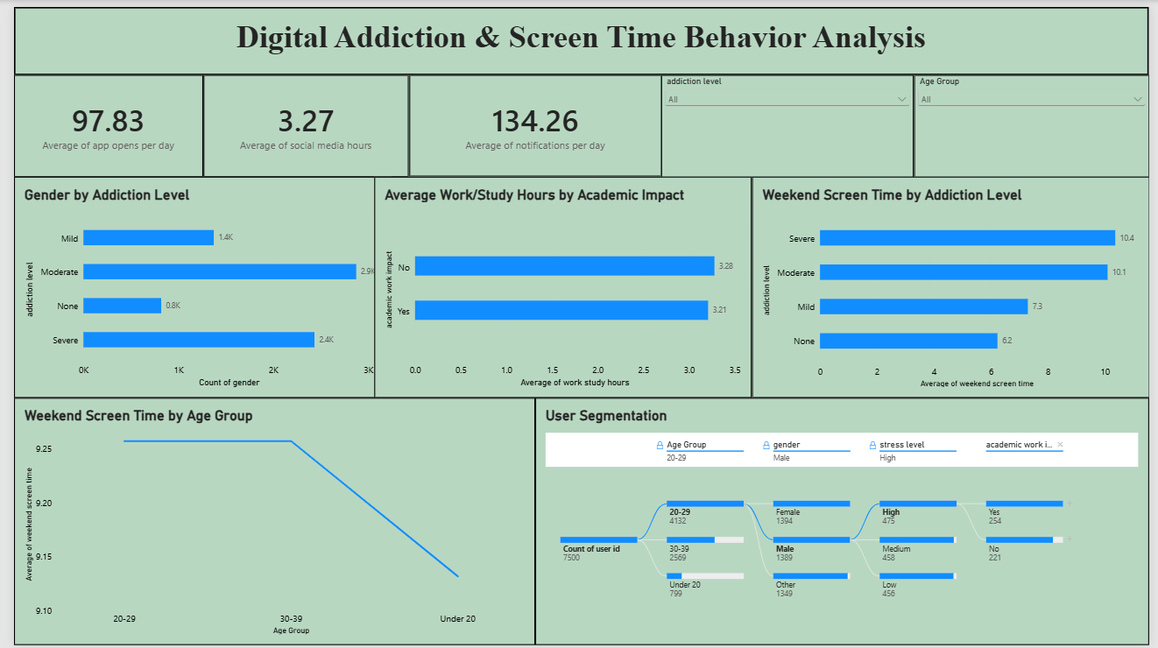

Observations drawn from the Report page in Power BI provide valuable insights into smartphone usage patterns and digital well-being trends.
1. Trends Over Time:
The line chart of weekend screen time by age group shows usage peaks in the 20-29 group (9.25 hrs) and declines through 30-39 down to Under 20 (9.10 hrs), suggesting weekend usage patterns shift with age.
2. Performance Comparisons:
Weekend screen time by addiction level shows a clear gradient: Severe users average 10.4 hrs, Moderate 10.1 hrs, Mild 7.3 hrs, and None 6.2 hrs, confirming addiction severity tracks closely with weekend usage volume.
3. Customer Segmentation:
The decomposition tree segments all 7,500 users by Age Group, gender, stress level, and academic/work impact - for example, of the 4,132 users aged 20-29, 1,394 are Female, of whom 475 report High stress, and 254 of those report academic/work impact.
4. Goal Achievement:
Average daily notifications (134.26), app opens per day (97.83), and social media hours (3.27) serve as tracked indicators of digital engagement intensity, useful for measuring whether future interventions reduce compulsive usage over time.
Example:
Gender by Addiction Level:
The chart shows Moderate addiction has the highest count (2.9K users), followed by Severe (2.4K), Mild (1.4K), and None (0.8K), across the gender-split view.
Academic Impact and Work/Study Hours:
Users reporting no academic/work impact average slightly more study hours (3.28) than those reporting impact (3.21), a negligible difference suggesting work/study hours alone do not explain reported academic impact.
Weekend Screen Time Disparities:
The Severe addiction group has the highest average weekend screen time at 10.4 hours, nearly 68% higher than the None group (6.2 hours), reinforcing screen time as the key addiction indicator.
User Segmentation Depth:
Drilling into the 20-29 age group (4,132 users), segmentation shows Female users (1,394) with High stress (475) as a specific at-risk subgroup worth targeted follow-up.

